Software development lifecycle :
The Software Development Life Cycle (SDLC) is a structured framework used by software organizations to design, develop, and test high-quality software. It defines the entire process of software production, from the initial idea to the final deployment and maintenance.
The goal of the SDLC is to produce high-quality software that meets or exceeds customer expectations, reaches completion within time and cost estimates, and is efficient to maintain.
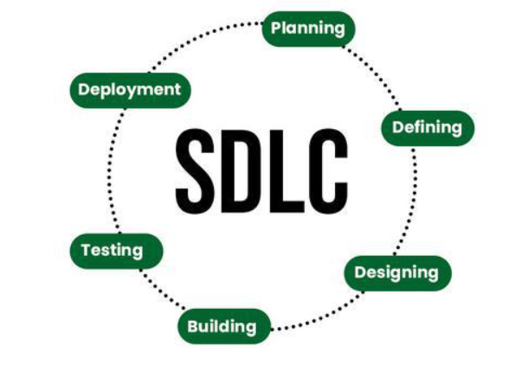
Stages of SDLC :
1.Requirement Document : This is the first and one of the most important phases of SDLC. The goal is to clearly understand what the client or user wants from the software. Activities included in planning stage are :
- Interacting with stakeholders (client, managers, end users).
- Collecting functional and non-functional requirements.
- Understanding constraints, expected features, and performance needs.
2.Technical Document : After requirements are finalized, the next step is designing the system architecture. Performed by team lead and the architect and is freezed after several reviews. Activities include :
- Selecting the technology stack (programming language, framework, database).
- Designing the database model (ER diagram, schema).
- Designing system architecture (client–server, cloud, microservices).
- Creating data flow diagrams, class diagrams, APIs, and module designs.
3.Coding Phase : This is the phase where the actual software is created based on the technical design. Coding is done by SSE , SE. Activities in this pahse are :
- Developers write code for each module
- Follow coding standards and best practices
- Use version control tools like Git
- Perform unit testing while coding
- Regular integration to ensure modules work together
The coding phase converts the design into a functional product.
4.Testing Phase : Once the code is written, it moves to the Quality Assurance (QA) team. The goal is to find bugs before the customer does. The main aim is to Detect bugs, verify functionality, ensure quality and reliability.
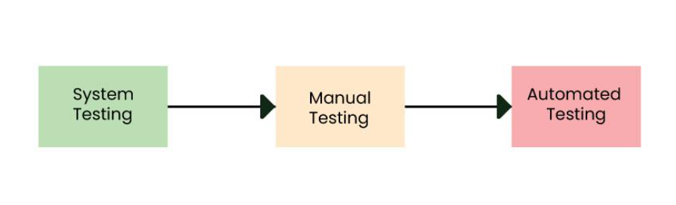
Types of testing include :
- Unit Testing: Testing small modules individually
- Integration Testing: Checking if modules work together
- System Testing: Testing the entire application
- Performance Testing: Checking speed and load handling
- Security Testing: Ensuring data protection and safe access
5.Staging Environment : A staging environment is a near-production environment used to test the application before it goes live. Regressing testing is done .Activities include :
- Ensure everything works exactly as it will in real users’ environment.
- Perform final UAT (User Acceptance Testing).
- Identify any last-minute issues before deployment.
- Go live.
Staging acts as the final checkpoint before real deployment.
6.Maintainance : A bug is an error, flaw, or unexpected behaviour in the software. Fix the bugs which comes during deployment.
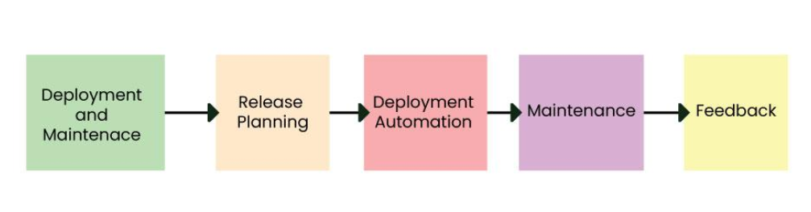
Activities include :
- Bug reported in tracking tool
- Developer fixes the bug
- Tester verifies the fix
- Bug marked as closed or reopened
Managing bugs properly ensures software reliability.
The Software Development Life Cycle (SDLC) is not a one-time process—it is a continuous and repetitive cycle. Once a software product is deployed, new requirements, feature enhancements, performance improvements, or bug fixes often arise. Whenever new changes are needed, the SDLC begins again from the requirement phase, followed by design, coding, testing, and deployment.

